Hussain Ather

Calculating the Percent Volume of Ethanol in Wine by Distillation

S117

Professors de Souza and Iyengar

UAI: Cody Haycraft

Lab Partners: Bryce Manifold, Jay Parekh

Calculating the Percent Volume of Alcohol in Wine

**Introduction**

Quantitative and qualitative analysis determine chemical and physical properties of substances. The structures of molecules, such as ethanol, affect these properties, such as boiling point. Through distillation, the percent volume of ethanol in wine can be analyzed along with ethanol’s boiling point and intermolecular forces in order to understand the role that the structure of ethanol plays in those properties.

**Questions**

How does the structure of ethanol affect its boiling point?

Why is the boiling point of water higher than that of ethanol?

How many H-bonds can water form with other water molecules? Ethanol with ethanol?

**Procedure**

The distillation apparatus was set up. The water hose was attached from tap to the bottom outlet on the apparatus. The other hose was attached from the top outlet to the sink. A beaker was placed at the end of the apparatus so that it will collect the condensed liquid form the condenser. 100.0 mL wine was poured and measured into a graduated cylinder. It was noted white or red wine and that continued to be used for the rest of the experimentation. For this experiment, white was used. The wine was poured from the cylinder into the round flask to be heated, and 2-3 boiling chips were placed into the flask as well. The rest of the apparatus was attached to the condenser with the thermometer on top, and the Keck clips were used to secure it. The cold water was turned on to start the condenser. “Watch for water leaks while the experiment is running” (Reck). The heating mantle was plugged into the VARIAC, and the VARIAC, into the wall. Starting at setting 6, the heat was turned on slowly raise the temperature as the liquid starts heating up. It continued to be raised until the wine boils. When distillate drops start to form, the start time was recorded. When temperature reached 95 degrees Celsius, the mantle was turned off. The temperature was not ever left to rise above 95 degrees. The experiment was kept cooling and reheating until all the ethanol is condensed. When all of the ethanol is condensed, the mantle was turned off. The stop time was noted and recorded to have a general idea of how long the experiment would take in order to plan the other trials. The rest of the condensed distillate was collected in the condenser into the beaker. The chips were discarded and the rest of the wine was disposed in normal garbage and sink, respectively. An empty cylinder was weighed, the distillate was added, and the final mass was noted to determine the weight of the distillate. With the same cylinder, the volume of the distillate was noted. This was repeated until three successful trials were obtained with the same wine. For this lab, only two trials were performed due to an error made in the third trial.

After the data was obtained from the experiment, the mass and volume of the distillate was used to calculate its density. Find this density on Table 1 and the consequent weight percent of alcohol in the distillate. Interpolation was used to calculate the weight percent of alcohol in the distillate. This weight percent was multiplied by the distillate mass to find the mass of the ethanol in the distillate. This was divided by the density of pure ethanol to find the volume of the ethanol. This was divided by the original volume of wine to find the percent volume ethanol in wine.

**Results**

After two trials, the average percent ethanol in wine by volume was determined to be 11.25% (11.25 mL).

|  |  |  |
| --- | --- | --- |
| Trial 1 | Trial 2 | Avg |
| 8. 69 g ethanol | 9.07 g ethanol | 8.88 g ethanol |
| 11.0 mL ethanol | 11.5 mL ethanol | 11.25 mL ethanol |
| 11.0 % ethanol | 11.5 % ethanol | 11.25% ethanol |

Table 1: The masses, volumes, and percentages of alcohol from the two trials were measured. The white wine sample had about 11.25% wine.

|  |  |
| --- | --- |
| Trial 1 | Trial 2 |
| 100.0 mL white wine | 100.0 mL white wine |
| 75.90 g grad cylinder | 75.94 g |
| 17.9 mL distillate | 18.9 mL |
| 16.21 g distillate | 17.17 |
| 92.11 g distillate + cylinder | 93.11 g |
| .908 g/mL distillate | .908 g/mL |
| 53.6% mass ethanol in distillate | 52.8% |

Table 2: Other calculations in the experiment. These were used to determine density, interpolation, volume alcohol, and percent alcohol.

Chart 1: The class data was collected for each white wine distillation. The results of this experiment (group 2) are lower than most of the others, but still close to the actual value (12.0%).

|  |  |
| --- | --- |
| Avg % Volume of ethanol | Std Dev |
| 13.70 | 5.20 |
| 11.25* | 0.35 |
| 12.50 | 0.85 |
| 14.00 | 2.97 |
| 10.20 | 5.37 |

*our group

Table 3: This table compares the average percent ethanol for each trial with standard deviations. Our data is close (though not the closest) to the actual value with the lowest standard deviation, showing a good degree of accuracy and prevision.

**Sample Calculations**

Density of distillate

$\frac{16.21 g distillate}{17.9 mL}$ = .906 g/mL

Interpolation

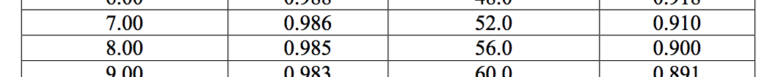 $(Reck)$ $$\frac{.910\frac{g}{mL}- .906 g/mL}{.910\frac{g}{mL}- .9 g/mL}=.4$$

.4(56.0 – 52.0) = 1.60

52.0 + 1.60 = 53.6% mass ethanol in distillate

Volume alcohol

$$.536 mass ethanol × 16.21 g dist.=8.69 g eth. × \frac{mL}{.789 g eth.}=11.0 mL ethanol$$

% Volume ethanol

$$\frac{11.0 mL eth}{100.0 mL white wine}=11.0\% ethanol$$

Average % ethanol

$$\frac{11.0 \%+11.5 \%}{2}=11.25 \% ethanol$$

Std Dev

${\left[{({11.25-11.5)}^{2}+{\left(11.0-11.25\right)}^{2}}^{}\right]}^{1/2}$ = .354

% error

$$\frac{12.0\% eth actual-11.25\% avg experimental}{12.0\%}$$

=6.25% error

**Discussion**

After two trials, the average % ethanol by volume was 11.25% with a standard deviation of .354, and it was expected to be about 12%, showing a good degree of accuracy. If ethanol condensed onto the inner sides of the round bulb, it would not reach the thermometer and/or condenser. Since it was assumed that all the ethanol would evaporate and be transferred to the beaker, this source of error would make the calculated value of percentage lower than the actual percentage. This is a moderately important source of error. Any distillate that stuck to the inside of the collecting beaker while moving it to the graduated cylinder would not be able to be collected. This would also make the calculated value lower. This would be the most important source of error.

The experiment could be improved with more trials to ensure more accurate data and more statistical analysis. A more precise heat mantle with the knowledge of exactly how much heat would be put into the system would improve the experiment by giving the ability to calculate the heat needed to raise the alcohol up to its boiling point. A greater top surface area of the liquid wine in the rounded bulb flask would allow the alcohol to evaporate faster and, therefore, allow the experiment to run faster. This would allow more trials to be included. Future areas of research could include determining the concentration of impurities in the wine and the effect of ethanol percentage of wine and the human body.

**Conclusion**

Ethanol has an –OH group. The electronegativity of oxygen draws electrons closer to itself and away from the hydrogen. This creates an electric gradient that draws other ethanol molecules towards each other. Oxygen from other ethanol molecules are pulled towards the Hydrogen and hydrogen from other ethanol molecules are pulled towards the lone electron pairs on the oxygen. This creates H-bonds (hydrogen bonds). Ethanol’s H-bonds allow ethanol molecules to have strong intermolecular forces. Since it requires a great force to separate those molecules, ethanol would have a high boiling point.

A single ethanol molecule can form H-bonds with about two other ethanol molecules while a single water molecule can form H-bonds with about four other water molecules, causing water molecules to have stronger intermolecular forces. The exact number of H-bonds actually varies with time and temperature (Chaplin). In ice, water molecules are H-bonded with four others. In liquid, some are broken in order for the molecules to move past one another. However, the H-bond strength of water is still stronger than that of ethanol. This makes the boiling point of water higher than that of ethanol. Also, water molecules are smaller and, therefore, pack more easily into its tetrahedral structure. This raises the boiling point.

Fig 1: A comparison of a single hydrogen bond between two Ethanol molecules (ChemHume) and four hydrogen bonds between water molecules. Since water can form more H-bonds, it has stronger IMF’s.

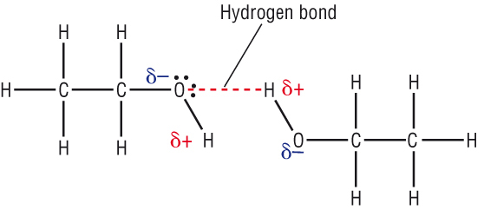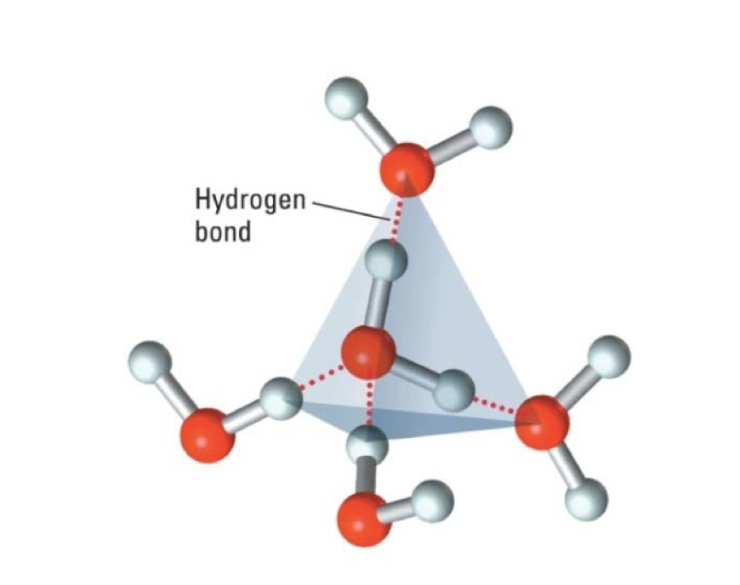

References

Chaplin, Martin. "Water’s Hydrogen Bond Strength." *ArXiv*. Cornell University Library, n.d. Web.

ChemHume. "Making Ethanol." *A Level Chemistry*. ChemHume, n.d. Web. 02 Sept. 2013.

Iyengar, Srinivasan. Lab lecture.

Reck, Stone, Robinson, and Arnold. "Determining the % Volume of Alcohol in Wine." *Chemistry C117/S117 Principles of Chemistry and Biochemistry Laboratory Manual*. By Dean. 7th ed. N.p.: Hayden-McNeil, 2008. N. pag. Web. 2 Sept. 2013. <http://courses.chem.indiana.edu/s117/documents/PercentVolumeofAlcoholinWine.pdf>.